Andrew Rutherford

CSCI 4113

Homework 2

1. History | awk ‘{a[$2]++}END{for(I in a){print a[i] “ “ i}}’ | sort –rn | head
2. 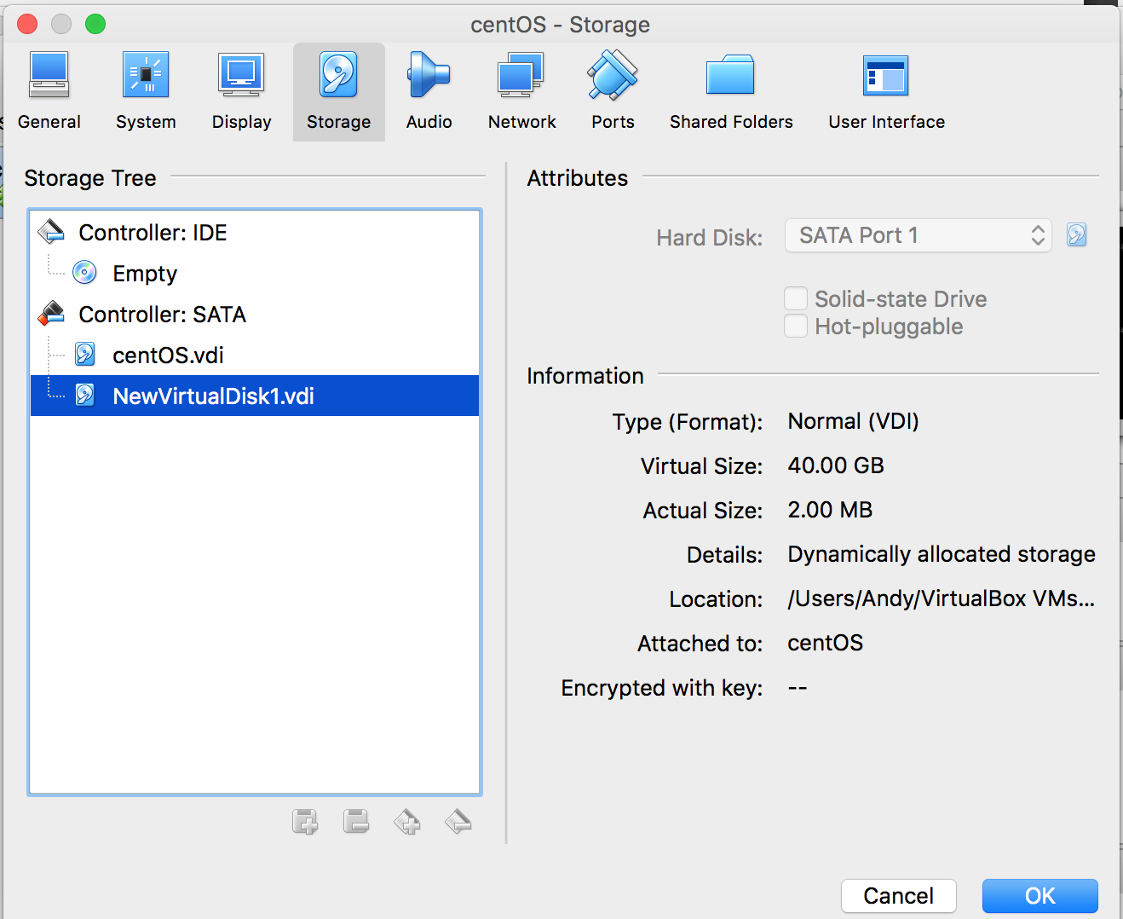
3. 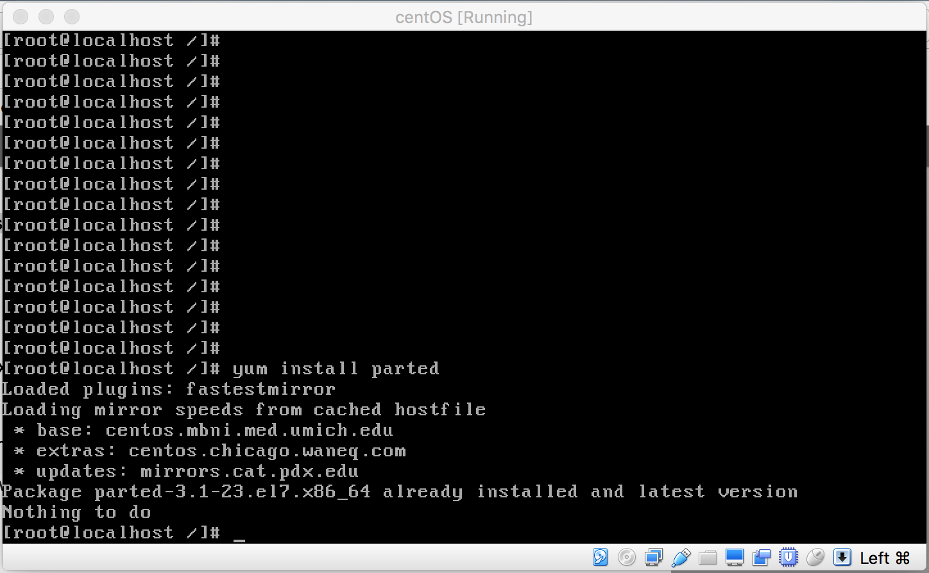
4. No topics were muddy from last week.
5. Ctrl-A will return the cursor to the beginning of the current command line. Useful if you are running a long script/command and realize something at the very beginning of it needs to be changed.